TMT/Rudra Constructions Nanded/S0514/2025 22-10-2025

To,
Rudra Constructions Nanded,
Anand nagar raj moll office no 201,
Gst = 27AZPPM2863F1Z0,
Mobile: +91 99227 23172.

Dear Sir,

Sub: - Supply of Hydraulic Three Roller Plate Bending machine width Pre-Pinching

We thank you for your inquiry regarding Plate Bending machine for SS plate width 4000 mm and thickness 32 mm. We are glad to inform you that we would be in a position to do the required equipment. Given below are the specifications and description of the machine and our terms and conditions.

S No | Description of the unit | Offer
1. | Three Roller Plate Bending machine for bending capacity, width 4000 and thickness 32 mm along with cone bending facility and along with complete electrical. | Rs 1,20,00,000/- (Rupees One Crore Twenty Lakhs Only)

Specifications of the equipment

1) Maximum width of the plate that can be rolled : 4000 MM

2) Maximum thickness of the plate that can be rolled : 32 MM

3) Top Roll diameter : 600 MM

4) Bottom Roller Diameter : 500 MM

5) Minimum Rolling Diameter : 1350 MM

6) Rolling speed : 1.6 RPM

7) Maximum yield limit of the plate : 345 Mpa.

8) Total power : 259 HP

Hydraulic power pack: 50 Hp + 50 hp + 20 hp
Return pump hp: 7.5 Hp -1 no’s
Air blast cooler: 10 hp - 2 no’s
Lubricant pump: 2hp

GENERAL TERMS & CONDITIONS:

- Price quoted per unit ex-work. Hyderabad.
- Following charges are additional to your account.
- Freight Charge : As actual to be borne by you.
- Excise : Extra As Applicable
- Sales Tax : 18% GST
- Packing charge : As actual to be borne by you.
- Insurance : As actual to be borne by you.
- Payment : Mutually Discussed
- Delivery : after receiving advance 8-10 weeks
- Validity : One month from the date of submission.
- Inspection : Inspection at our works prior to dispatch.
- Warranty : The machine is warranted for a period of 12 months from the date of dispatch against any manufacturing defects/ faulty material or bad workmanship of any part or component but not against any kind of abnormal or improper use of machine. Defective part or component will be replaced or repaired free of cost. Electrical components are outside the scope of this warranty.
- Commissioning : Erection & commissioning done by you, but required technical support & guidance provide by us at additional cost.

NOTE:
- Oil is not in scope of our supply.
- Raw material for trial is to be arranged by you at your cost.

We are sure you will find our offer in line with your requirements. For further clarifications if any, please contact T. Sivaramakrishna, 9849207176 / 9246221106. Email: tmthyde@gmail.com

Thanking you and assuring you of our best services.

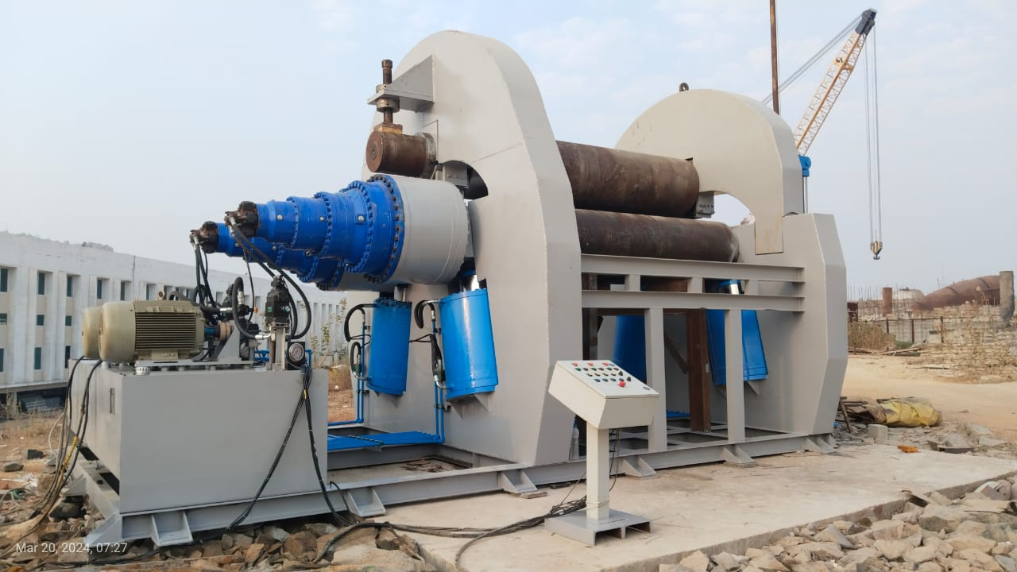

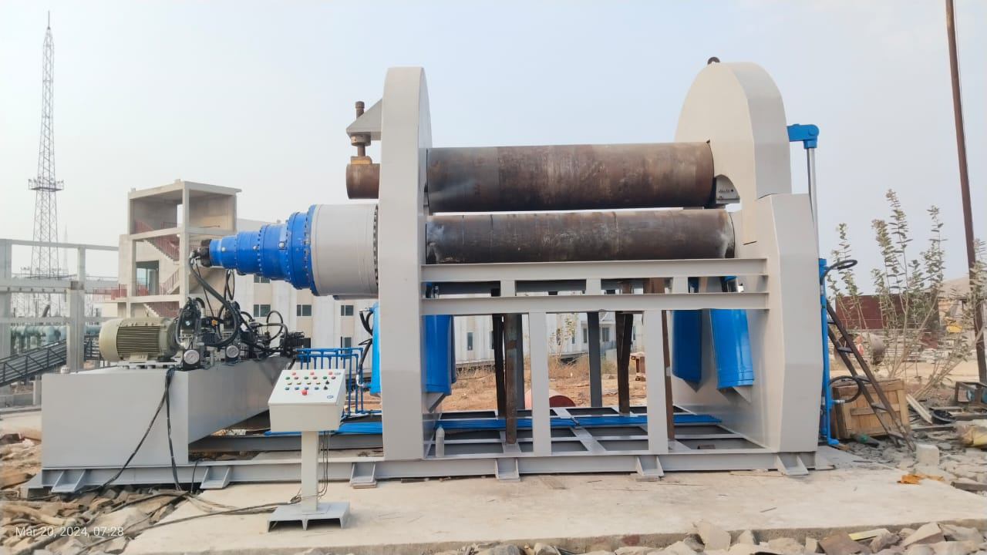

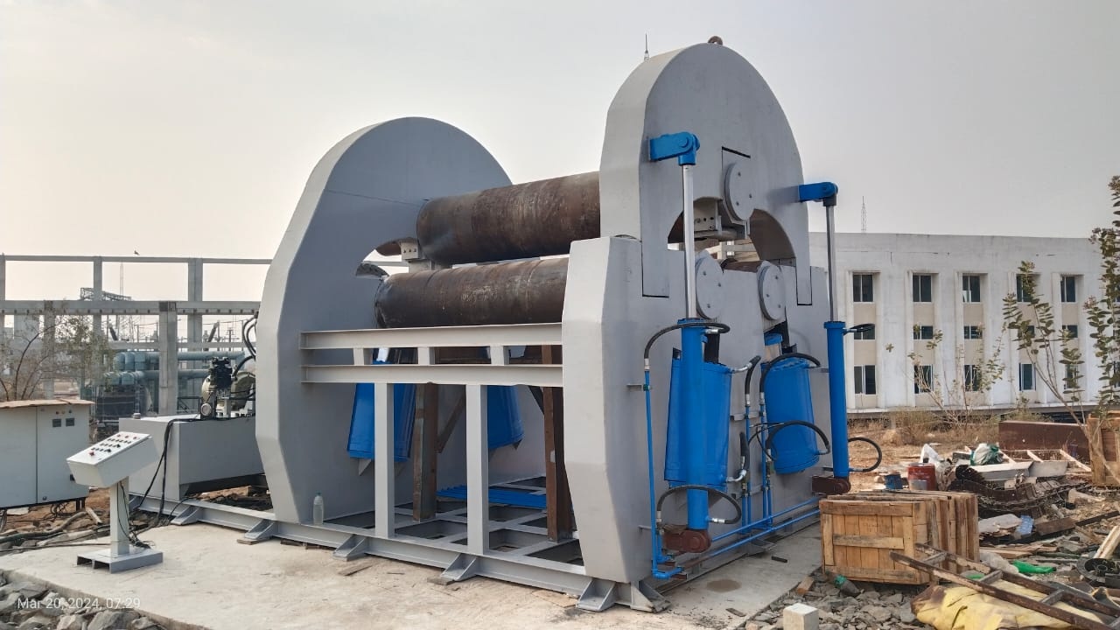

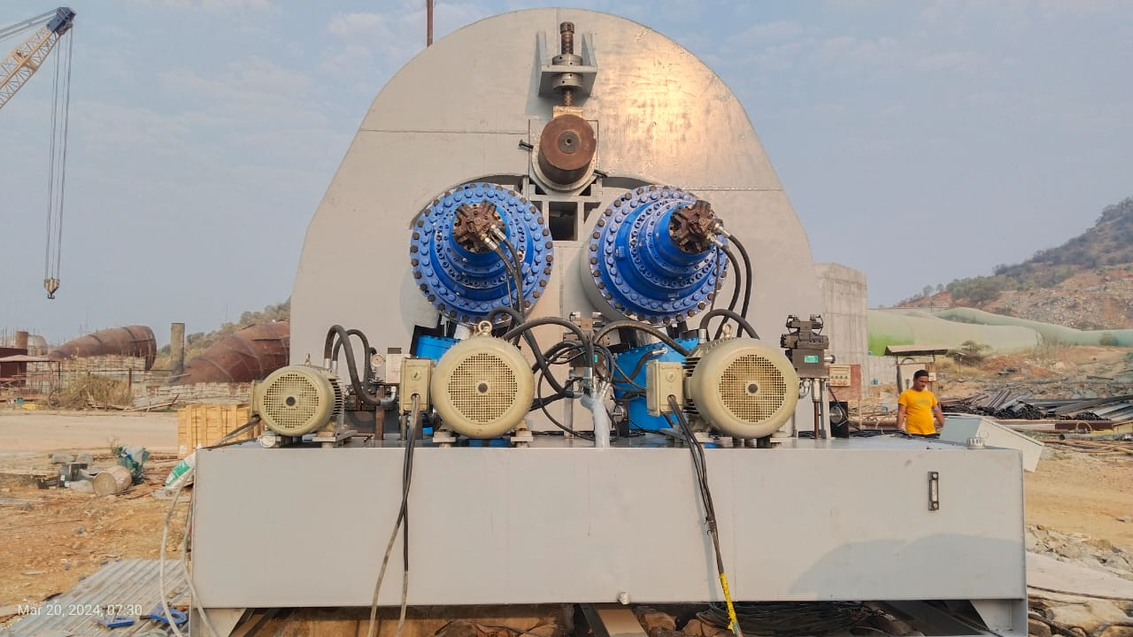

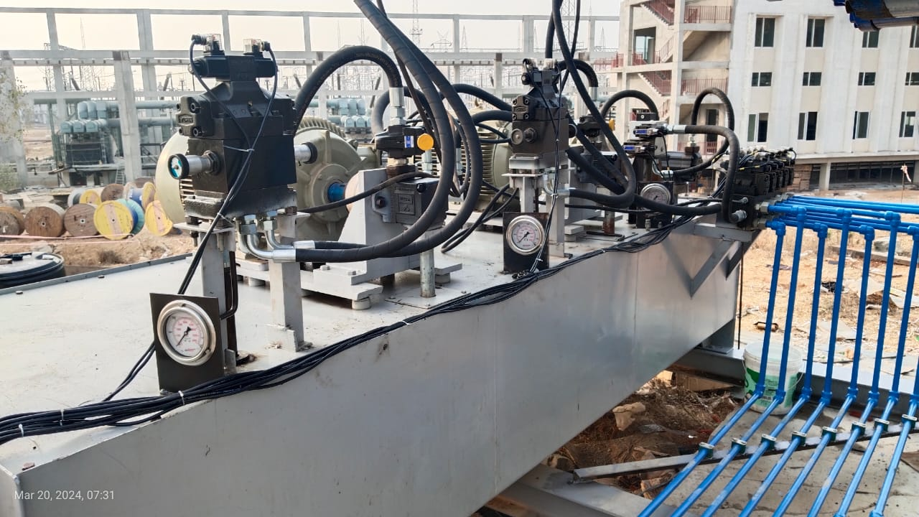

For TECHNO MACHINE TOOLS

(T. SIVARAMAKRISHNA)

